GFIT Test Framework Defect Workflow

# Detailed explanation.

The code put in by Edward Moore simply limited the list of available options in the status list presented to the user as a quick and easy solution.

The code in the TCOE/IF used a very large IF THEN statement in workflow to manage both permitted transitions and introduce role based control which worked but was slow and complicated.

Neither of these are the best way to implement both transition and role control in ALM. There is built in functionality to achieve this located here:

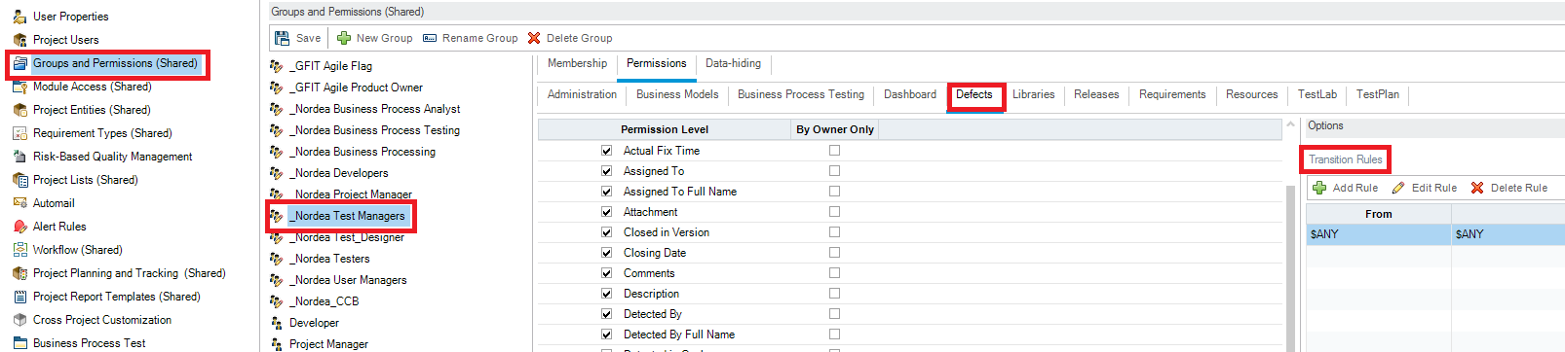

So that’s in customization, Groups and permissions. Select the group, select the defects tab and then select the field to which you want to apply the transition rules then on the right the rules are presented. Here test manager has ANY to ANY permission.

Build the transition rules here and don’t bother with workflow.

I have removed all the defect transition related workflow code. Both mine and Björns.

# Specific Changes from Group IT Template.

Any group ( except TDADMIN ) who had an $ANY to $ANY transition rule has had it removed to protect the integrity of the workflow.

All other transition rules have been removed.

All custom roles that are not used in the template have had all transition rules removed. These are:

* _Nordea Business process analyst
* _Nordea Business Process Testing
* _Nordea Business Processing
* _Nordea Project Manager
* _Nordea Test Designer
* _Nordea User Managers
* _Nordea CCB

I have not and cannot change the built in roles!

# Agile

There is a group called “GFIT Agile Flag”. This group should be added to all agile team members. It permits all the transitions that are allowed in the diagram.

# Transition Table

This is exactly what has been implemented in each role.

|  |  |  |  |  |  |  |
| --- | --- | --- | --- | --- | --- | --- |
| **From** | **To** | **Test Manager** | **Test Engineer** | **Developer** | **Agile Flag** | **Product Owner** |
| New | Reopen | ✗ | ✗ | ✗ | ✗ | ✗ |
| Open | New | ✗ | ✗ | ✗ | ✗ | ✗ |
| Assigned | Open | ✗ | ✗ | ✗ | ✗ | ✗ |
| In progress | Assigned | ✗ | ✗ | ✗ | ✗ | **✗** |
| Fixed | In progress | ✗ | ✗ | ✗ | ✗ | ✗ |
| Retest | Fixed | ✗ | ✗ | ✗ | ✗ | ✗ |
| Closed | Retest | ✗ | ✗ | ✗ | ✗ | ✗ |
| Rejected | Closed | ✗ | ✗ | ✗ | ✗ | ✗ |
| CR | Rejected | ✗ | ✗ | ✗ | ✗ | ✗ |
| postponed | CR | ✗ | ✗ | ✗ | ✗ | ✗ |
| Reopen | postponed | ✗ | ✗ | ✗ | ✗ | ✗ |
| New | postponed | ✗ | ✗ | ✗ | ✗ | ✗ |
| Open | Reopen | ✗ | ✗ | ✗ | ✗ | ✗ |
| Assigned | New | ✗ | ✗ | ✗ | ✗ | ✗ |
| In progress | Open | ✗ | ✗ | ✗ | ✗ | **✗** |
| Fixed | Assigned | ✗ | ✗ | ✗ | ✗ | ✗ |
| Retest | In progress | ✗ | ✗ | ✗ | ✗ | ✗ |
| Closed | Fixed | ✗ | ✗ | ✗ | ✗ | ✗ |
| Rejected | Retest | ✗ | ✗ | ✗ | ✗ | ✗ |
| CR | Closed | ✗ | ✗ | ✗ | ✗ | ✗ |
| postponed | Rejected | ✗ | ✗ | ✗ | ✗ | ✗ |
| Reopen | CR | ✗ | ✗ | ✗ | ✗ | ✗ |
| New | CR | ✗ | ✗ | ✗ | ✗ | ✗ |
| Open | postponed | **✓** | ✗ | ✗ | ✗ | **✓** |
| Assigned | Reopen | ✗ | ✗ | ✗ | ✗ | ✗ |
| In progress | New | ✗ | ✗ | ✗ | ✗ | **✗** |
| Fixed | Open | ✗ | ✗ | ✗ | ✗ | ✗ |
| Retest | Assigned | ✗ | ✗ | ✗ | ✗ | ✗ |
| Closed | In progress | ✗ | ✗ | ✗ | ✗ | ✗ |
| Rejected | Fixed | ✗ | ✗ | ✗ | ✗ | ✗ |
| CR | Retest | ✗ | ✗ | ✗ | ✗ | ✗ |
| postponed | Closed | ✗ | ✗ | ✗ | ✗ | ✗ |
| Reopen | Rejected | ✗ | ✗ | ✗ | ✗ | ✗ |
| New | Rejected | ✗ | ✗ | ✗ | ✗ | ✗ |
| Open | CR | ✗ | ✗ | ✗ | ✗ | ✗ |
| Assigned | postponed | ✗ | ✗ | ✗ | ✗ | ✗ |
| In progress | Reopen | ✗ | ✗ | ✗ | ✗ | **✗** |
| Fixed | New | ✗ | ✗ | ✗ | ✗ | ✗ |
| Retest | Open | ✗ | ✗ | ✗ | ✗ | ✗ |
| Closed | Assigned | ✗ | ✗ | ✗ | ✗ | ✗ |
| Rejected | In progress | ✗ | ✗ | ✗ | ✗ | ✗ |
| CR | Fixed | ✗ | ✗ | ✗ | ✗ | ✗ |
| postponed | Retest | ✗ | ✗ | ✗ | ✗ | ✗ |
| Reopen | Closed | ✗ | ✗ | ✗ | ✗ | **✓** |
| New | Closed | ✗ | ✗ | ✗ | ✗ | ✗ |
| Open | Rejected | ✗ | ✗ | ✗ | ✗ | ✗ |
| Assigned | CR | ✗ | ✗ | ✗ | ✗ | ✗ |
| In progress | postponed | ✗ | ✗ | ✗ | ✗ | **✗** |
| Fixed | Reopen | ✗ | ✗ | ✗ | ✗ | ✗ |
| Retest | New | ✗ | ✗ | ✗ | ✗ | ✗ |
| Closed | Open | ✗ | ✗ | ✗ | ✗ | ✗ |
| Rejected | Assigned | ✗ | ✗ | ✗ | ✗ | ✗ |
| CR | In progress | ✗ | ✗ | ✗ | ✗ | ✗ |
| postponed | Fixed | ✗ | ✗ | ✗ | ✗ | ✗ |
| Reopen | Retest | ✗ | ✗ | ✗ | ✗ | ✗ |
| New | Retest | ✗ | ✗ | ✗ | ✗ | ✗ |
| Open | Closed | **✓** | ✗ | ✗ | ✗ | ✗ |
| Assigned | Rejected | **✓** | **✓** | **✓** | **✓** | **✓** |
| In progress | CR | ✗ | ✗ | ✗ | ✗ | **✗** |
| Fixed | postponed | ✗ | ✗ | ✗ | ✗ | ✗ |
| Retest | Reopen | **✓** | **✓** | ✗ | **✓** | **✓** |
| Closed | New | ✗ | ✗ | ✗ | ✗ | ✗ |
| Rejected | Open | ✗ | ✗ | ✗ | ✗ | ✗ |
| CR | Assigned | ✗ | ✗ | ✗ | ✗ | ✗ |
| postponed | In progress | ✗ | ✗ | ✗ | ✗ | ✗ |
| Reopen | Fixed | ✗ | ✗ | ✗ | ✗ | ✗ |
| New | Fixed | ✗ | ✗ | ✗ | ✗ | ✗ |
| Open | Retest | ✗ | ✗ | ✗ | ✗ | ✗ |
| Assigned | Closed | ✗ | ✗ | ✗ | ✗ | ✗ |
| In progress | Rejected | ✗ | ✗ | ✗ | ✗ | **✗** |
| Fixed | CR | ✗ | ✗ | ✗ | ✗ | ✗ |
| Retest | postponed | ✗ | ✗ | ✗ | ✗ | ✗ |
| Closed | Reopen | ✗ | ✗ | ✗ | ✗ | ✗ |
| Rejected | New | ✗ | ✗ | ✗ | ✗ | ✗ |
| CR | Open | ✗ | ✗ | ✗ | ✗ | ✗ |
| postponed | Assigned | ✗ | ✗ | ✗ | ✗ | ✗ |
| Reopen | In progress | ✗ | ✗ | ✗ | ✗ | ✗ |
| New | In progress | ✗ | ✗ | ✗ | ✗ | ✗ |
| Open | Fixed | ✗ | ✗ | ✗ | ✗ | ✗ |
| Assigned | Retest | ✗ | ✗ | ✗ | ✗ | ✗ |
| In progress | Closed | ✗ | ✗ | ✗ | ✗ | **✗** |
| Fixed | Rejected | ✗ | ✗ | ✗ | ✗ | ✗ |
| Retest | CR | ✗ | ✗ | ✗ | ✗ | ✗ |
| Closed | postponed | ✗ | ✗ | ✗ | ✗ | ✗ |
| Rejected | Reopen | ✗ | ✗ | ✗ | ✗ | ✗ |
| CR | New | ✗ | ✗ | ✗ | ✗ | ✗ |
| postponed | Open | **✓** | ✗ | ✗ | ✗ | **✓** |
| Reopen | Assigned | **✓** | ✗ | ✗ | ✗ | ✗ |
| New | Assigned | ✗ | ✗ | ✗ | ✗ | ✗ |
| Open | In progress | ✗ | ✗ | ✗ | ✗ | ✗ |
| Assigned | Fixed | ✗ | ✗ | ✗ | ✗ | ✗ |
| In progress | Retest | ✗ | ✗ | ✗ | ✗ | **✗** |
| Fixed | Closed | ✗ | ✗ | ✗ | ✗ | ✗ |
| Retest | Rejected | ✗ | ✗ | ✗ | ✗ | ✗ |
| Closed | CR | ✗ | ✗ | ✗ | ✗ | ✗ |
| Rejected | postponed | ✗ | ✗ | ✗ | ✗ | ✗ |
| CR | Reopen | ✗ | ✗ | ✗ | ✗ | ✗ |
| postponed | New | ✗ | ✗ | ✗ | ✗ | ✗ |
| Reopen | Open | ✗ | ✗ | ✗ | ✗ | ✗ |
| New | Open | **✓** | **✓** | ✗ | **✓** | ✗ |
| Open | Assigned | **✓** | ✗ | ✗ | ✗ | ✗ |
| Assigned | In progress | **✓** | **✓** | **✓** | **✓** | **✓** |
| In progress | Fixed | **✓** | **✓** | **✓** | **✓** | **✓** |
| Fixed | Retest | **✓** | ✗ | ✗ | ✗ | ✗ |
| Retest | Closed | **✓** | **✓** | ✗ | **✓** | **✓** |
| Closed | Rejected | ✗ | ✗ | ✗ | ✗ | ✗ |
| Rejected | CR | **✓** | ✗ | ✗ | ✗ | **✓** |
| CR | postponed | ✗ | ✗ | ✗ | ✗ | ✗ |
| postponed | Reopen | ✗ | ✗ | ✗ | ✗ | ✗ |
| Reopen | New | ✗ | ✗ | ✗ | ✗ | ✗ |

This is a tabular implementation of this:

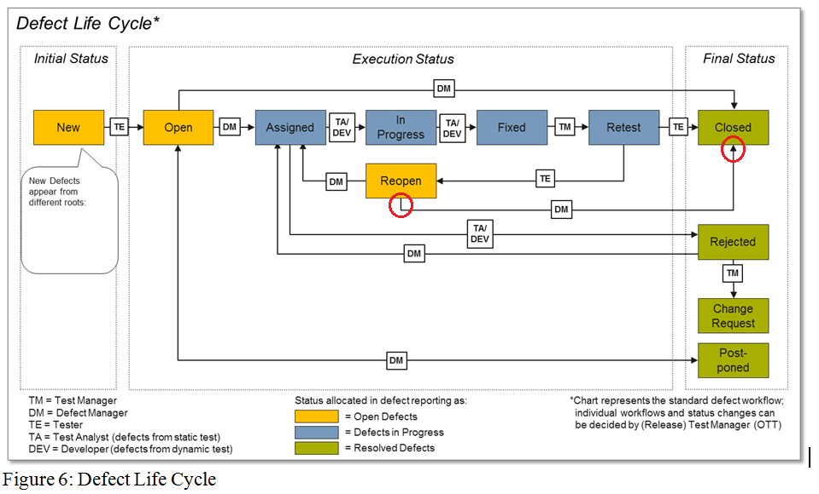

Note as per the diagram and the email confirmation there is no way back from “closed” for any role.